 | 7.79 Acres with Creek Frontage & Large Gravel Pad  File #P154
  Land Size: | 7.79 Acres
  Price: | $120,000
  Area: | Mat-Su South Central (Meadow Lakes area)
  Legal  Description: | Tract C Garrison Ridge Phase I; Palmer Recording District; Plat #2020-112
  Directions: | 3579 N. Meadow Lakes Loop: Parks Highway north to approx. mile 48.8; rt on Pittman Road; left on Meadow Lakes Loop; see lot on left.
  Access: | Paved maintained road.
  Waterfront: | Frontage on Little Meadow Creek.
  Utilities: | Electric in area (Meadow Lakes Loop Road); Gas adjacent on Meadow Lakes Loop Road.
  Covenants: | None; unrestricted
  Buildings: | None; property has been improved with a large gravel pad.
  Surveyed: | Yes; the corners were originally marked with 5/8” rebar w/plastic caps as noted on plat.
  Taxes: | Approx $543.34 yr
  Terms: | Cash
  Remarks:
 | 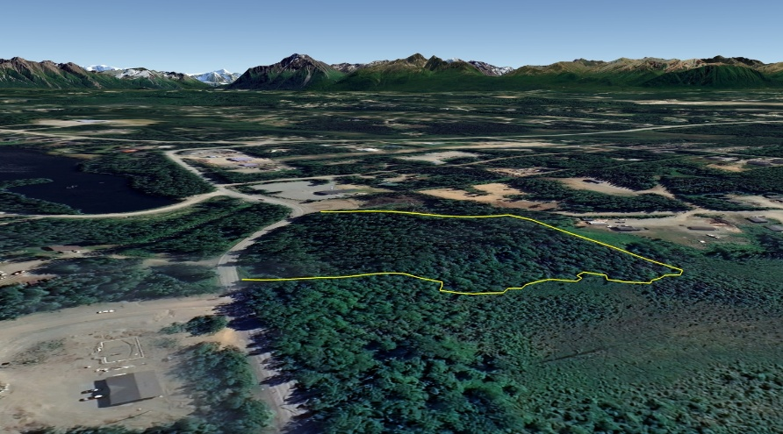
DISCLAIMER: Statewide Real Estate LLC does not guarantee the completeness or the accuracy of the material furnished in this brochure. Potential buyers are strongly advised to seek professional help in determining the availability, quality and cost of water, sewageable soils, and utilities. A survey may be necessary to locate property corners; GPS coordinates are approximate. Potential buyers should independently verify the zoning requirements and permits required with the appropriate agencies to determine if the property is suitable for their intended use.

